Recommended Immunization Schedule for Persons Aged 0 Through 6 Years—United States • 2010
For those who fall behind or start late, see the catch-up schedule

Vaccine ▼ Age ►

Birth
1

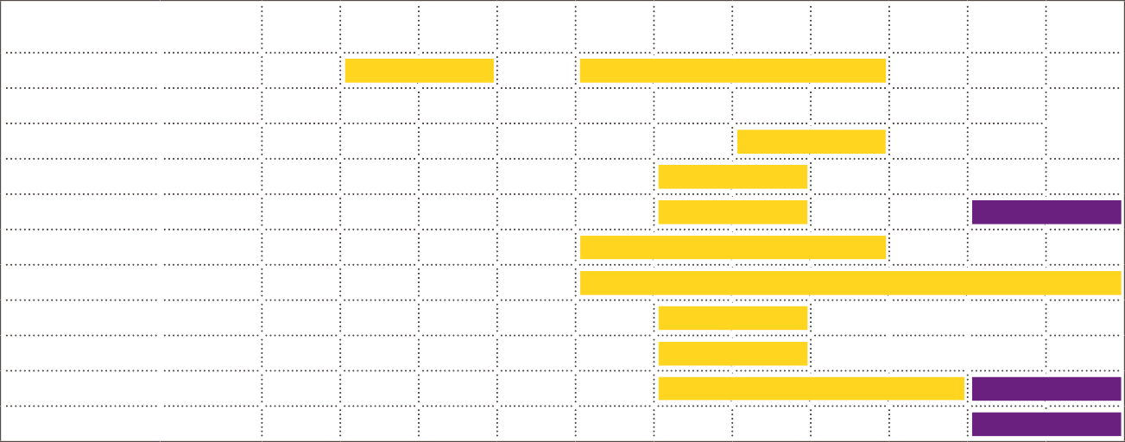
month
2

months
4

months
6

months
12

months
15

months
18

months
19–23
months
2–3

years
4–6

years

Hepatitis B1 HepB

HepB
HepB

Rotavirus2 RV RV RV 2
3

see
Range of
recommended

Diphtheria, Tetanus, Pertussis

DTaP DTaP DTaP
footnote 3

DTaP DTaP
ages for all

Haemophilus influenzae type b4 Hib Hib Hib4
Hib
children except
certain high-risk

Pneumococcal5 PCV PCV PCV
Inactivated Poliovirus6 IPV IPV
Influenza7
Measles, Mumps, Rubella8 Varicella9

PCV IPV

MMR
Varicella

Influenza (Yearly)
see footnote 8
see footnote 9

PPSV
IPV

MMR
Varicella
groups

Range of recommended ages for certain high-risk groups

Hepatitis A10
Meningococcal11

HepA (2 doses)
HepA Series MCV

This schedule includes recommendations in effect as of December 15, 2009. Any dose not administered at the recommended age should be administered at a subsequent visit, when indicated and feasible. The use of a combination vaccine generally is preferred over separate injections of its equivalent component vaccines. Considerations should include provider assessment, patient preference, and the potential for adverse events. Providers should consult the relevant Advisory
Committee on Immunization Practices statement for detailed recommendations: http://www.cdc.gov/vaccines/pubs/acip-list.htm. Clinically significant adverse events that follow immunization should be reported to the Vaccine Adverse Event Reporting System (VAERS) at http://www.vaers.hhs.gov or by telephone, 800-822-7967.

- Hepatitis B vaccine (HepB). (Minimum age: birth)

At birth:
  - Administer monovalent HepB to all newborns before hospital discharge.
  - If mother is hepatitis B surface antigen (HBsAg)-positive, administer HepB and 0.5 mL of hepatitis B immune globulin (HBIG) within 12 hours of birth.
  - If mother’s HBsAg status is unknown, administer HepB within 12 hours of birth. Determine mother’s HBsAg status as soon as possible and, if HBsAg- positive, administer HBIG (no later than age 1 week).

After the birth dose:
  - The HepB series should be completed with either monovalent HepB or a com- bination vaccine containing HepB. The second dose should be administered at age 1 or 2 months. Monovalent HepB vaccine should be used for doses administered before age 6 weeks. The final dose should be administered no earlier than age 24 weeks.
  - Infants born to HBsAg-positive mothers should be tested for HBsAg and antibody to HBsAg 1 to 2 months after completion of at least 3 doses of the HepB series, at age 9 through 18 months (generally at the next well-child visit).
  - Administration of 4 doses of HepB to infants is permissible when a combina- tion vaccine containing HepB is administered after the birth dose. The fourth dose should be administered no earlier than age 24 weeks.
Inactivated poliovirus vaccine (IPV) (Minimum age: 6 weeks)
  - The final dose in the series should be administered on or after the fourth
birthday and at least 6 months following the previous dose.
  - If 4 doses are administered prior to age 4 years a fifth dose should be admin-
istered at age 4 through 6 years. See MMWR 2009;58(30):829–30.
- Influenza vaccine (seasonal). (Minimum age: 6 months for trivalent inacti- vated influenza vaccine [TIV]; 2 years for live, attenuated influenza vaccine [LAIV])
  - Administer annually to children aged 6 months through 18 years.
  - For healthy children aged 2 through 6 years (i.e., those who do not have under- lying medical conditions that predispose them to influenza complications), either LAIV or TIV may be used, except LAIV should not be given to children aged 2 through 4 years who have had wheezing in the past 12 months.
  - Children receiving TIV should receive 0.25 mL if aged 6 through 35 months or 0.5 mL if aged 3 years or older.
  - Administer 2 doses (separated by at least 4 weeks) to children aged younger than 9 years who are receiving influenza vaccine for the first time or who were vaccinated for the first time during the previous influenza season but only received 1 dose.
  - For recommendations for use of influenza A (H1N1) 2009 monovalent vaccine
see MMWR 2009;58(No. RR-10).

* * * Free Preview End * * *
Purchase Required To Gain Total Access
Visit www.daycareenrollmentforms.com To Purchase Daycare Enrollment Forms

